SUBASHREE.N-192521377
LAB EXPERIMENTS
EXP 16: HIGH LEVEL PROGRAMMING EXTENSIONS: PROCEDURES
OUTPUT:
1:
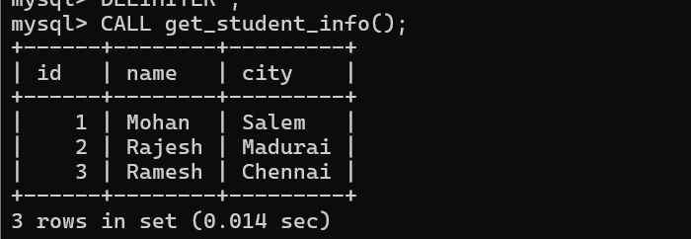
2:
